Physical Training Report
3rd year 2nd quarter
ECE CLASSES 18 November 2024
Little athelets in the making!
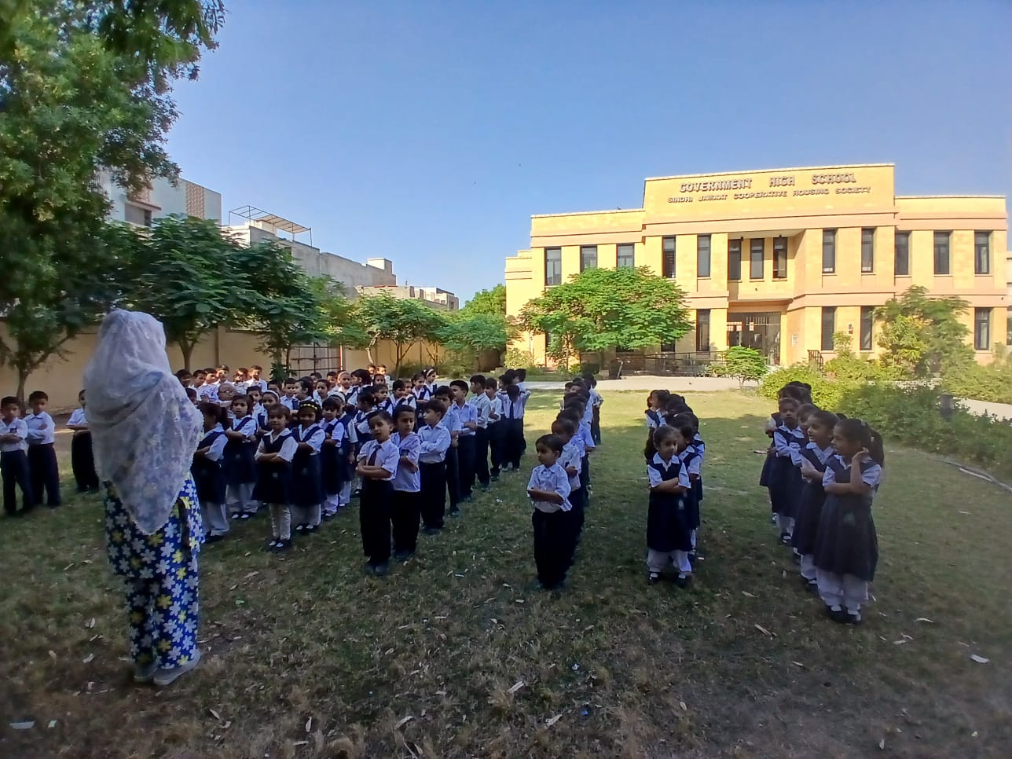

LEVEL 1 4 December 2024
PT time ! where fitness meets fun.!
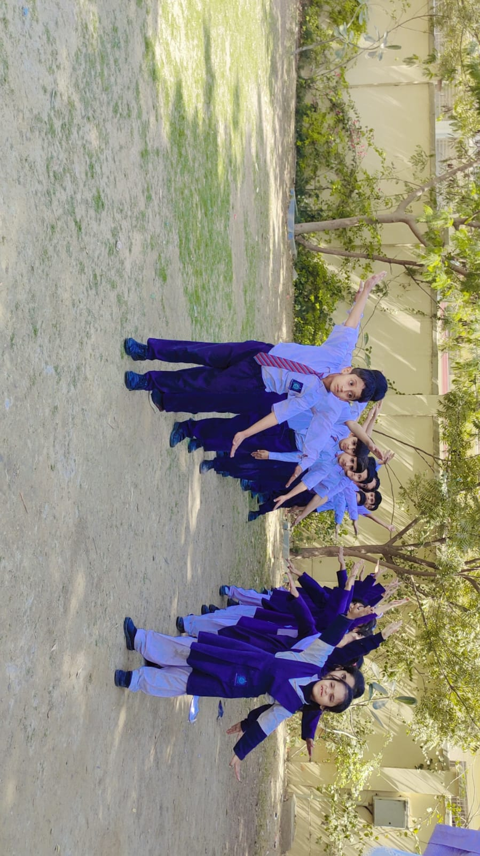
LEVEL 2 11 January 2025
PT time ! Healthy habbits Start here!
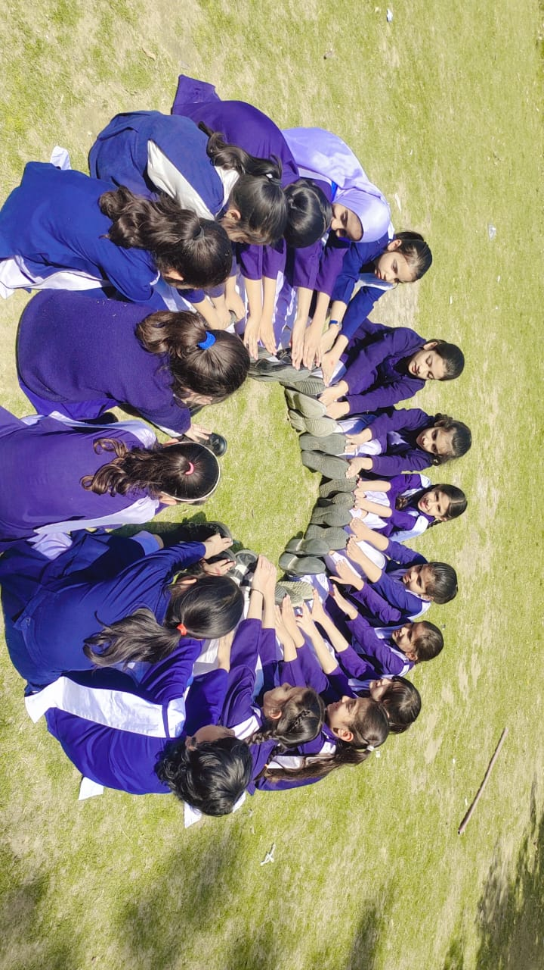

LEVEL 3 6 February 2025
PT Classes for young minds.
Play , learn & get fit .
